**Lab Assignment-6**

0 level Dfd-

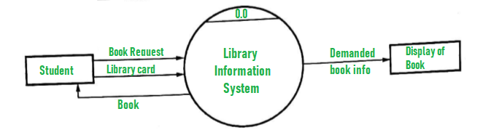

1 Level Dfd -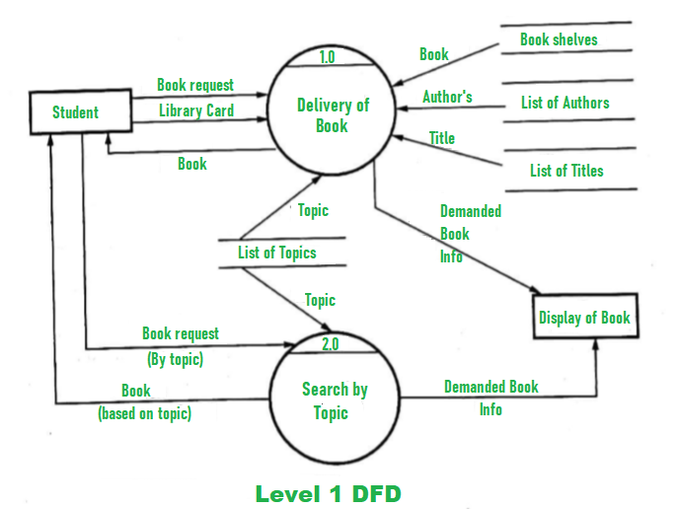

2 Level Dfd-

